**Practice Exercise – Easy**

**Directions (Q. Nos. 1 − 4):** *Study the pie chart below and answer the questions.*

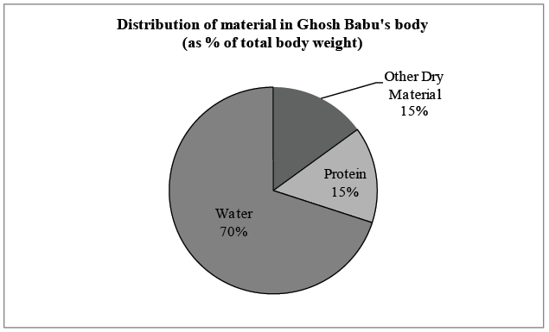

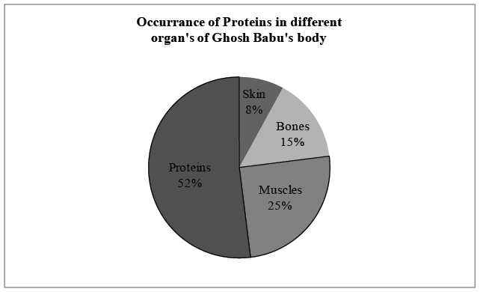

1. What fraction of Ghoshbabu’s weight consists of muscular and skin protein?

a.  b. 

c.  d. Cannot be determined

2. Ratio of distribution of protein in muscle to the distribution of protein in skin is: (approx.)

a. 3 : 1 b. 3 : 10 c. 1 : 3 d. 

3. What percent of Ghosh Babu’s body weight is made up of skin:

a. 0.15 b. 10

c. 1.2 d. Cannot be determined

4. In terms of total body weight, the portion of material other than water and protein is closest to:

a.  b. 

c.  d. 

**Directions (Q. Nos. 5 − 7):** *Answer the questions based on the following information.*

Chart (1) shows the distribution of 12 million tonnes of crude oil transported through different modes over a specific period of time. Chart (2) shows the distribution of the cost of transporting this crude oil. The total cost was Rs. 30 million.

**[CAT 2001]**

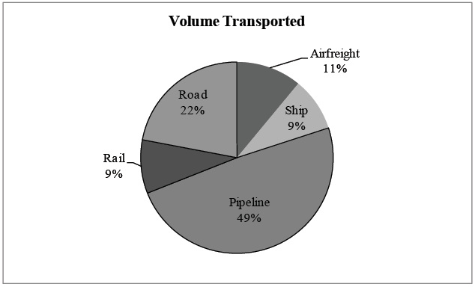

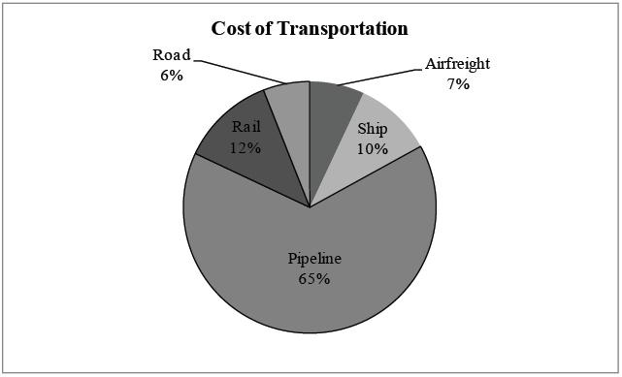

5. The cost in rupees per tonne of oil moved by rail and road happens to be roughly:

a. Rs. 3 b. Rs. 1.5 c. Rs. 4.5 d. Rs. 8

6. From the charts given, it appears that the cheapest mode of transport is:

a. Road b. Rail c. Pipeline d. Ship

7. If the costs per tonne of transport by ship, air and road are represented by P, Q and R respectively, which of the following is true?

a. R > Q > P b. P < R > Q

c. P > Q > R d. R > P > Q

**Directions (Q. Nos. 8 − 9):** *Answer the questions based on the following information.*

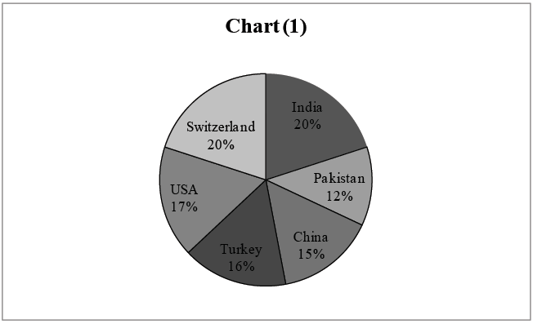

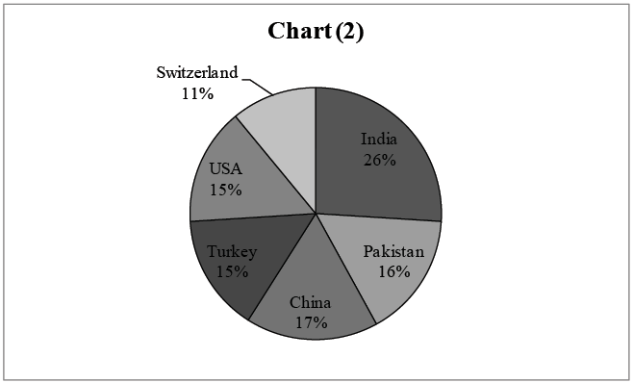

Chart (1) shows the distribution by value of top 6 suppliers of MFA Textiles in 1995. Chart (2) shows the distribution by quantity of top 6 suppliers of MFA Textiles in 1995. The total value is 5760 million Euro (European currency). The total quantity is 1.055 million tonnes. **[CAT 2002]**

8. The country which has the highest average price is:

a. USA b. Switzerland

c. Turkey d. India

9. The average price in Euro per kilogram for Turkey is roughly

a. 6.20 b. 5.80 c. 4.20 d. 4.80

**Directions (Q. Nos. 10 − 13):** *Answer the questions based on the following information.*

The number of electronic goods sold in India was 72 lakhs units in 2012. The electronic goods market has been growing at the rate of 15% per annum every year since 2012.

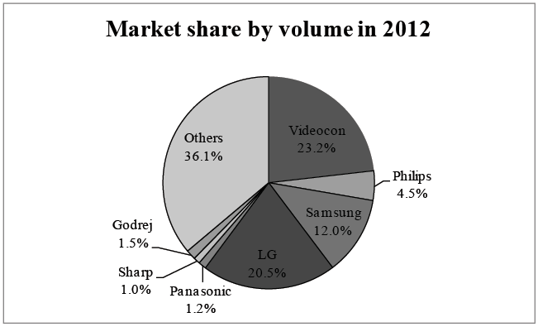

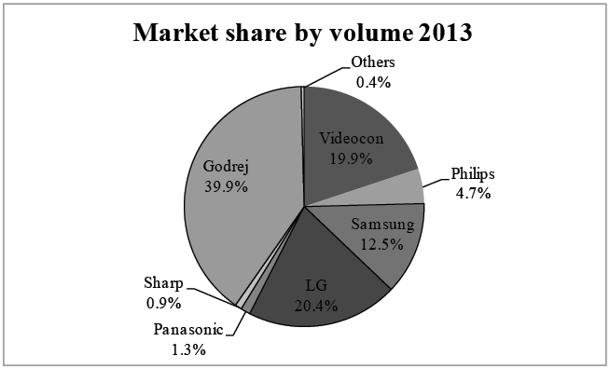

10. If Sharp sold 7400 units in march 2013, by how much is its sales above the average monthly sales for that year?

a. 25% b. 6.75% c. 7.25 d. None

11. If Samsung experience growth of 50% from 2013 to 2014 and the total sales of Samsung in 2014 is Rs. 6000 crores, then what is the average cost of each Samsung product?

a. Rs. 37,439

b. Rs. 35,721

c. Rs. 38,648

d. Cannot be determined

12. If the total sales of LG in 2012 is Rs. 10,500 crores, then what is the average price per product of LG in year 2013?

a. Rs. 41,700

b. Rs. 36,500

c. Rs. 38,600

d. Cannot be determined

13. Sharp spends heavily on marketing and in 2014 they have market share of 6.4% as a result. What is the number of units sold by Sharp in a month in 2014?

a. 6,09,408

b. 50,784

c. 48,862

d. 38,600

**Directions (Q. Nos. 14 − 17):** *Answer the questions based on the following information.*

The following pie charts show the percentage breakup of the agriculture for 2013 and 2014 of major foodgrains (areas) in India.

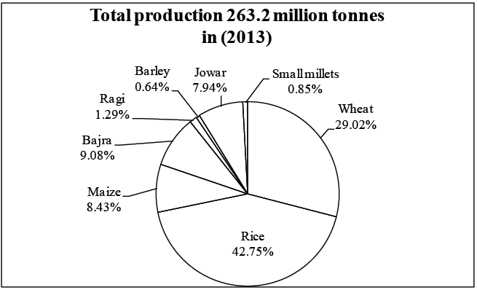

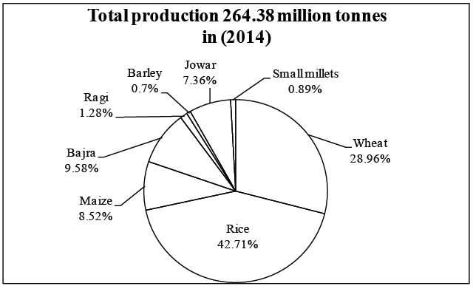

14. Which food grain shows the maximum in terms of the percentage increase in the share (of production) from 2013 to 2014?

a. Maize

b. Bajra

c. Barley

d. Small millets

15. If the per kg price of Rice is more than the per kg price of Wheat, then what is difference in total revenue earned by sales of these 2? (Consider total sales of Wheat + Rice = 3500 crores)

a`. Rs. 1500 crores

b. Rs. 2000 crores

c. Rs. 2250 crores

d. Cannot be determined

16. What is the difference in combined production of Maize and Barley between 2013 and 2014?

a. 0.5 mn tonnes

b. 1.8 mn tonnes

c. 2.7 mn tonnes

d. 3.4 mn tonnes

17. If foodgrains continue to increase at same rate as in year 2014, what will be the combined production of Ragi, Barley and Small millets in 2015? (Consider the same % breakup of 2014)

a. 5.18 mn tonnes

b. 8.76 mn tonnes

c. 7.62 mn tonnes

d. 11.26 mn tonnes

**Directions (Q. Nos. 18 − 20):** *Answer the questions based on the following information.*

The following pie charts show the imports and exports done by Sudan with various group of countries.

Imports and exports are US $ 4,80,000 and US $ 3,00,000 respectively for year 2014.

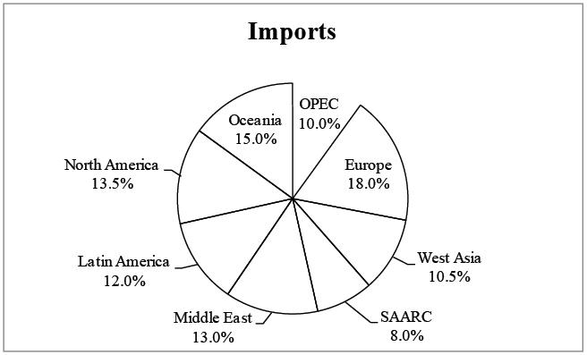

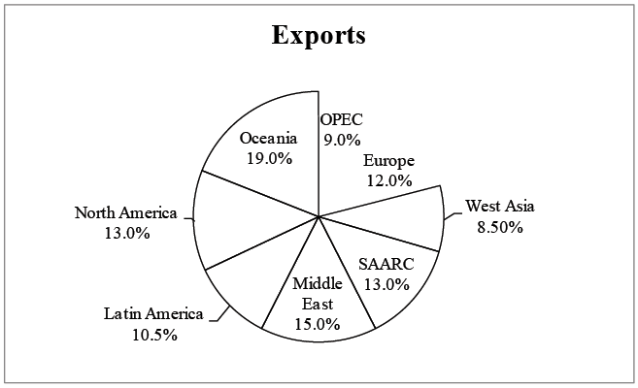

**Total Trade = Imports + Exports**

18. Imports form what percentage of total trade with the OPEC countries?

a. 60%

b. 58%

c. 64%

d. 72%

19. Had the exports with Latin America been US $ 38000, then what would have been the percentage of the exports with Latin America? (rest all values remaining same)

a. 10.8%

b. 11.6%

c. 10%

d. None of these

20. Which of the following has the least difference in imports and exports?

a. Europe

b. West Asia

c. Oceania

d. None of these

**Practice Exercise – Medium**

**Directions (Q. Nos. 1 − 5):** *Study the pie chart below and answer the questions.*

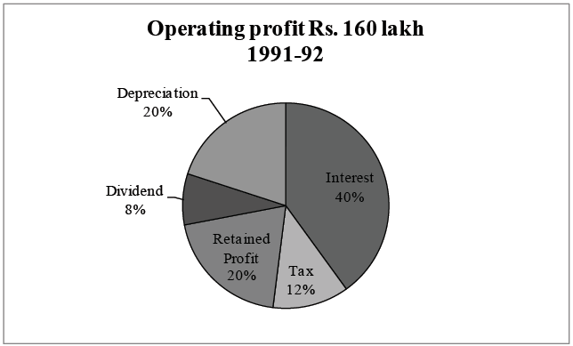

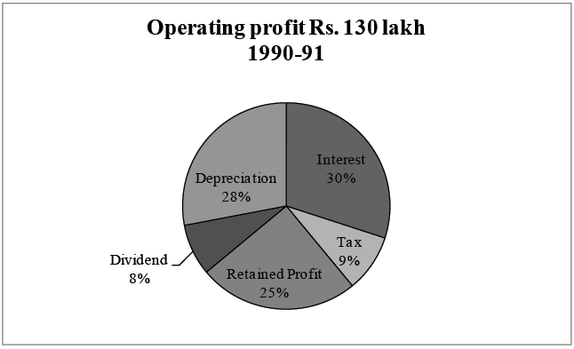

1. The operating profit in 1991-92 increased over that in 1990-91 by:

a. 23% b. 22% c. 25% d. 24%

2. The interest burden in 1991-92 was higher than that in 1990-91 by:

a. Rs. 50 lakh b. Rs. 25 lakh

c. Rs. 90 lakh d. Rs. 41 lakh

3. If on an average, 20% rate of interest was charged on borrowed funds, then the total borrowed funds used by this company in the given two years amounted to:

a. Rs. 221 lakh b. Rs. 195 lakh

c. Rs. 368 lakh d. Rs. 515 lakh

4. The retained profit in 1991-92, as compared to that in 1990-91 was:

a. Higher by 2.5% b. Higher by 1.5%

c. Lower by 2.5% d. Lower by 1.5%

5. The equity base of these companies remained unchanged. Then the total dividend earning by the share holders in 1991-92 is:

a. Rs. 104 lakh b. Rs. 9 lakh

c. Rs. 12.8 lakh d. Rs. 15.6 lakh

**Directions (Q. Nos. 6 − 10):** *Answer the questions based on the following information.*

The pie chars below show percentage of market share on revenue of Indian vehicle market in 2015. The market is divided into 2 segments vis. Passenger Vehicles & Commercial Vehicles.

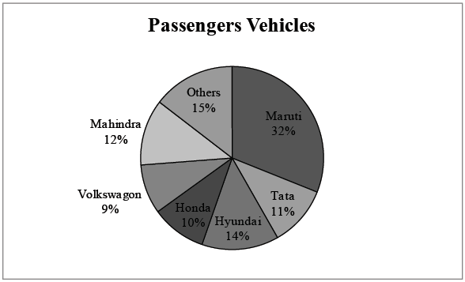

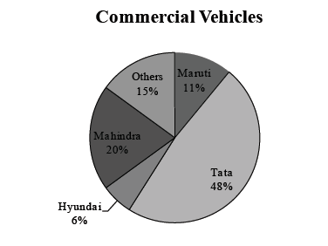

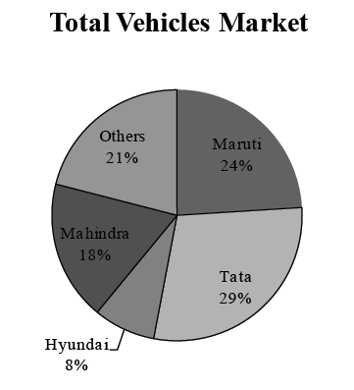

6. What is the ratio of percentage market share of Maruti in passengers vehicles to that of Tata in commercial vehicles?

a. 0.83

b. 0.66

c. 0.75

d. Cannot be determined

7. What will be the market of Maruti in passengers vehicles in 2016, if its sales in this category is twice its sales in 2015 in the passengers vehicles category?

a. 51.8%

b. 70%

c. 12.3%

d. Cannot be determined

8. If for Hyundai, in commercial vehicles, export sales constitute half of its total sales, then what is its market share in the exports segment of commercial vehicles?

a. 5.5%

b. 8%

c. 11%

d. Cannot be determined

9. If Maruti captures half of the market of the rest of the brands in the commercial vehicles segments, then its new market share in the commercial vehicles would be:

a. 18.5%

b. 47.5%

c. 55.5%

d. Cannot be determined

10. The total vehicle market share is Rs. 5000 crores in the year 2015. If Maruti, Tata and Hyundai grow by 10% in 2016, while Mahindra shows an increase of 15% and others decline by 5%, then what is the total vehicle market in year 2016?

a. Rs. 5100.51 crore

b. Rs. 5387.5 crore

c. Rs. 5409.11 crore

d. None of these

**Directions (Q. Nos. 11 − 15):** *Answer the questions based on the following information.*

The two pie charts give the percentage breakup of phones sales, one giving the type of phones produced and the other the manufactures producing the phones.

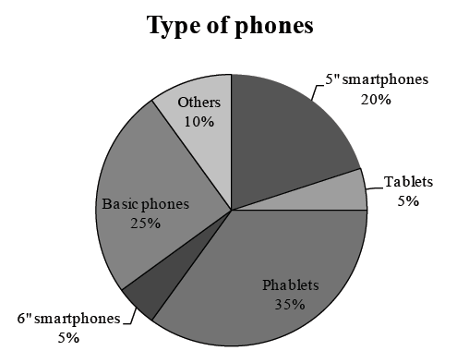

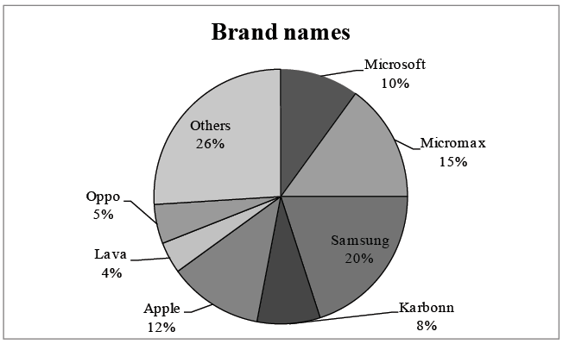

**Total sales = 251 million units**

11. How many units of basic phones are sold?

a. 62.75 mn

b. 70 mn

c. 56.75 mn

d. None of these

12. 30% of Tablets sold are manufactured by Samsung. What fraction of Samsung's sales are that of tablets?

a. 7.5% b. 10% c. 25% d. 6.6%

13. 50% of Micromax's sales consist of basic phones. What is Micromax's percentage share in basic phones sales?

a. 10%

b. 18%

c. 20%

d. 30%

14. What is the ratio of tablets manufactured by Oppo and Apple if Oppo and Lava have half of their productions as tablets and tablets are manufactured by only Oppo, Lave and Apple?

a. 7 : 2

b. 4 : 7

c. 5 : 1

d. 3 : 8

15. Oppo stops making phablets phones. If they had 7% share in sales of this type, what would be the percentage reduction in their overall sales ?

a. 31.38% b. 43.14% c. 48.92% d. 58.76%

**Directions (Q. Nos. 16 − 20):** *Answer the questions based on the following information.*

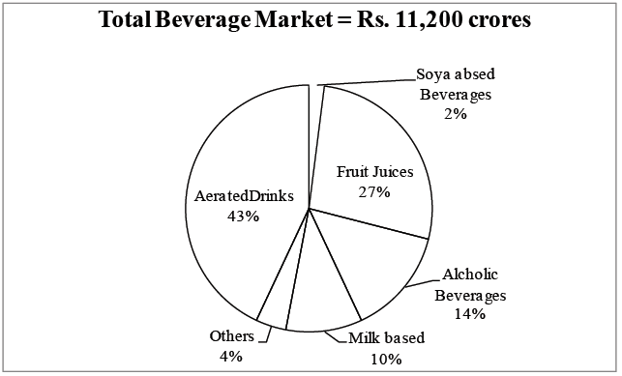

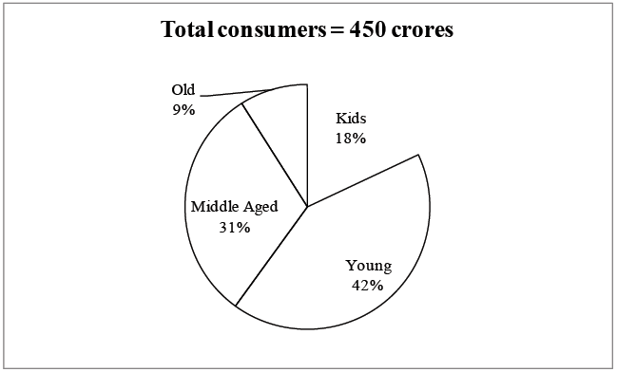

16. In the next year among the consumers of beverages among kids increased by 30%, among young increased by 50%, middle aged increased by 25% and the old decrease by 15%. What are the total number of consumers in the next year?

a. 528.13 crores

b. 746.87 crores

c. 597.6 crores

d. 932l.34 crores

17. Pepsi is the leader in aerated drinks with a market share of 53% and its Juice brand and Tropicana is the leader in Fruit Juice category with a market share of 47% while its water Aquafina is 22% of the others. What are the total sales of Pepsi Company in the beverage market?

a. 3918.57 crores

b. 5156.79 crores

c. 4072.32 crores

d. None of these

18. The industry experts decide to count the solidified milk as a part of beverage market and hence the total number of consumers grow by 30%. What is the new number of kids in the total consumers, if the solidified milk products of kids are also included in it?

a. 54 crores

b. 135 crores

c. 81 crores

d. Cannot be determined

19. The beverage market grew by 15% in the next 2 years and then by 20% and 25% respectively in the next 2 years. What will be the total market after 4 years?

a. 19,886 crores

b. 22,218 crores

c. 21,206 crores

d. 24,156 crores

20. Among kids, they drink only aerated drinks, fruit juices and milk based beverages. 20% of aerated drinks sale, 35% fruit juice sales and 50% milk based beverages sales are because of kids. What is the average spending (in Rs.) period on beverages?

a. Rs. 32.18

b. Rs. 28.63

c. Rs. 34.73

d. Rs. 31.87

**Practice Exercise – Difficult**

**Directions (Q. Nos. 1 − 4):** *Answer the questions based on the following information.*

The following pie charts represent the breakup of total exports and total imports of Madagascar in 2016.

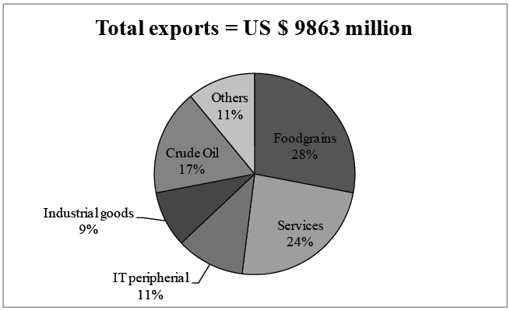

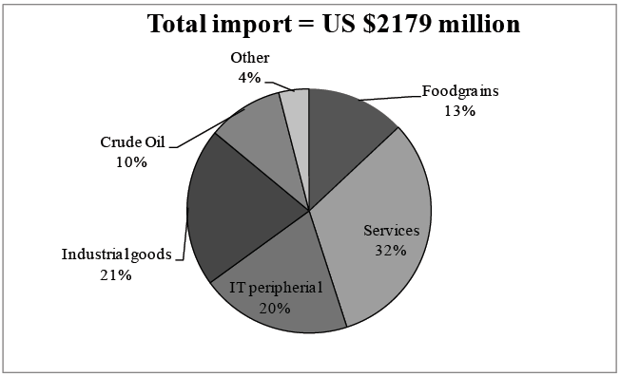

**Positive value is export surplus and negative will be import surplus**

**Trade Surplus = Total Exports − Total Imports**

1. The govt. of Madagascar is presenting is annual budget for the year 2017. The govt. has classified foodgrains and Crude Oil under natural resources and estimates their growth of imports at 10% and growth of exports at 15%. While all others have been classified under artificial resources and the imports of all artificial resources are expected to growth at 20% and exports of all artificial resources are expected to grow at 15%. By what percentage is the trade surplus of natural resources more than artificial resources in 2017?

a. 6.12%

b. 9.37%

c. 7.76%

d. 8.14%

2. If foodgrains exports are expected to increase by 10% for the next 5 years and the imports are expected to decrease by 10% for the next 5 years, then what will be the trade surplus from foodgrains after 5 years?

a. 4471.96 million

b. 4378.18 million

c. 4187.16 million

d. 4280.38 million

3. If for the next year, trade surplus for crude oil increase by 30% and that for services increase by 10%, then what would be the difference in trade surplus of both the segments?

a. Rs. 50 million

b. Rs. 59.62 million

c. Rs. 62.83 million

d. Rs. 48.16 million

4. If trade ratio is defined as ratio of total trade surplus to total exports for particular segment, then which of the following is false?

a. Trade ratio is highest for others.

b. Trade ratio is highest for foodgrains.

c. Trade ratio for foodgrains is less than that of crude oil.

d. Trade ratio is lowest for industrial goods.

**Directions (Q. Nos. 5 − 8):** *Answer the questions based on the following information.*

A sample set of 8300 Olympic athletes were exposed to a radically new training methodology towards preparation for Olympics. Out of this sample size, 72.29% athletes were male while the rest were female. Among these athletes, 44.57% have already heard about this technique being used by Australia to train their athletes.

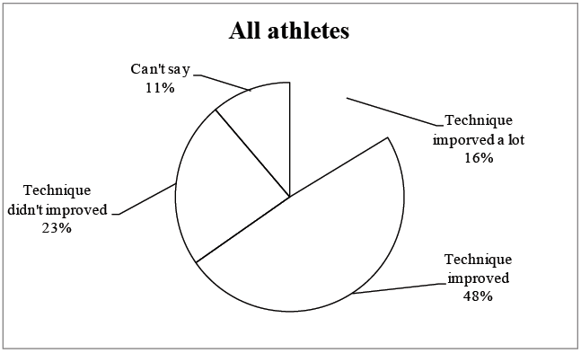

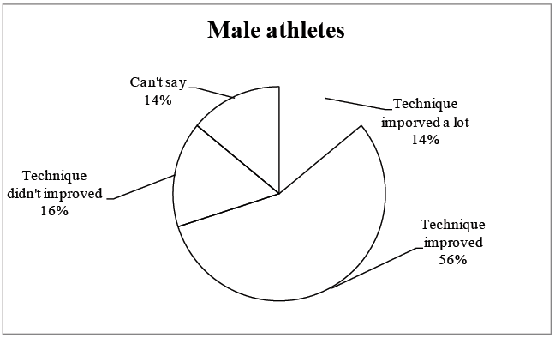

[**Note:** Number of athletes in any category is a whole number]

5. For how many female athletes rated the technique improved a lot?

a. 413

b. 436

c. 488

d. 524

6. What is the ratio of male to female athletes who can't say anything about the new training program?

a. 9.33

b. 1.87

c. 16.67

d. 11.50

**Additional directions (Q. Nos. 7 − 8):** *Athletes who have not heard about this training regime earlier, out of them 22.43% technique improved a lot while these who heard about this regime earlier only 8% say their technique improved a lot.*

7. Find the difference in the number of athletes who said among those who heard about the regime for the first time and those who had heard about it earlier.

a. 1390

b. 1186

c. 736

d. Data insufficient

8. Among the males what is the ratio of athletes who have heard about this and their technique improved a lot to the athletes who have not heard about this and their technique improved?

a. 0.75

b. 1.5

c. 1.75

d. Data insufficient

**Directions (Q. Nos. 9 − 13):** *Answer the questions based on the following information.*

The following 6 pie charts show the break up of number of stories by 6 writers viz. Jhumpa, Amartya, Chetan, Ravinder, Arvind and Amish in 6 different books (collections of short stories).

Each writer has written atleast 1 story in each of the books.   
Each pie chart shows the number of stories of 3 of the writers while others are included in the others.

For each writer an index called 'Writers Curse' is calculated which is the difference between the minimum and maximum number of stories any writer can write in total in these 6 books.

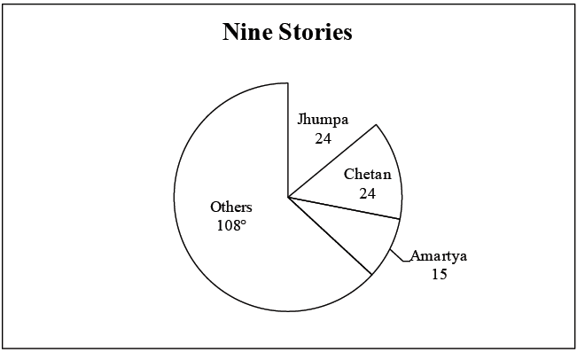

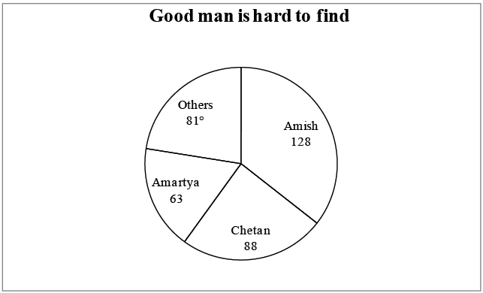

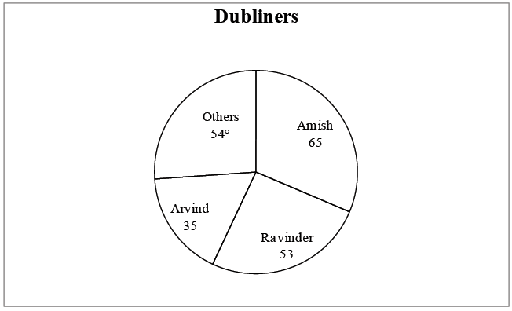

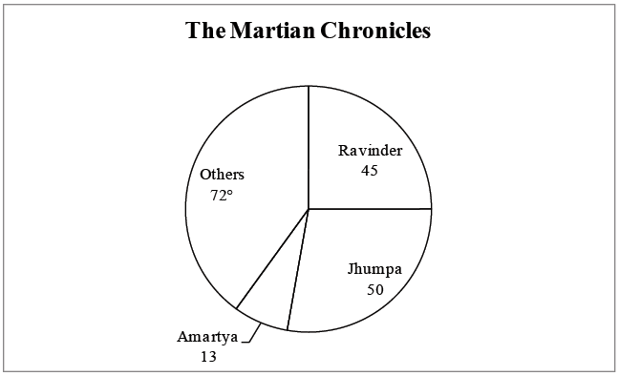

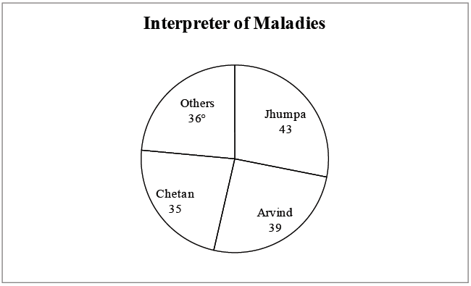

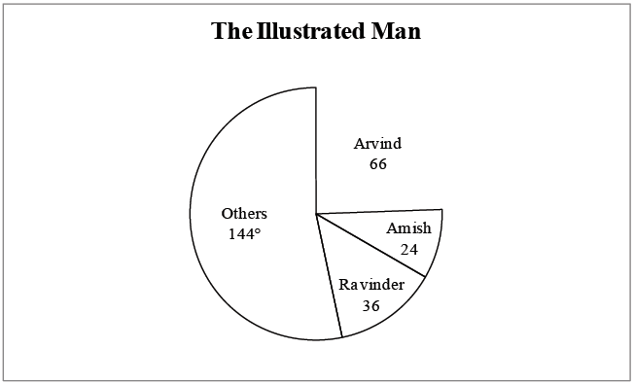

9. The total number of stories developed by how many persons is definitely more than the number of stories developed by Amartya in total?

a. 0

b. 1

c. 2

d. 3

10. Who has the lowest 'Q Index' among all the 6 persons?

a. Jhumpa

b. Amartya

c. Amish

d. Chetan

11. Find the complete list of persons, any one of the which could have developed the minimum number of stories.

a. Jhumpa, Amartya

b. Jhumpa, Amartya, Chetan, Ravinder

c. Jhumpa, Amartya, Chetan, Ravinder, Arvind

d. Jhumpa, Amartya, Ravinder, Arvind

**Additional directions (Q. Nos. 12 − 13):** *A writer is 'Star performer' if there definitely are atleast two books in which the number of stories developed is lesser than the number of stories developed in that book by that person and definitely at least two books in which the number of stories developed is greater than the number of stories developed in that books by that writer.*

12. How many writers have a "Star Performance" book.

a. 0

b. 1

c. 2

d. None of these

13. Which of the books is not a star performance book for any of the writers?

a. Dubliners

b. Nine stories

c. The Martian Chronicles

d. All the books

**Directions (Q. Nos. 14 − 18):** *Answer the questions based on the following information.*

The following pie-charts give the information regarding the area wise distribution of the number of 4's and 6's questions in a season of IPL and also the team wise distribution of the runs scored by Gayle.

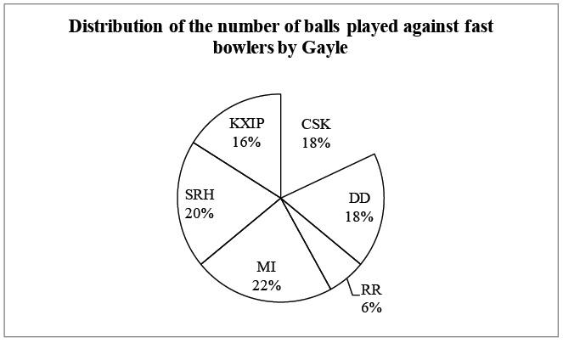

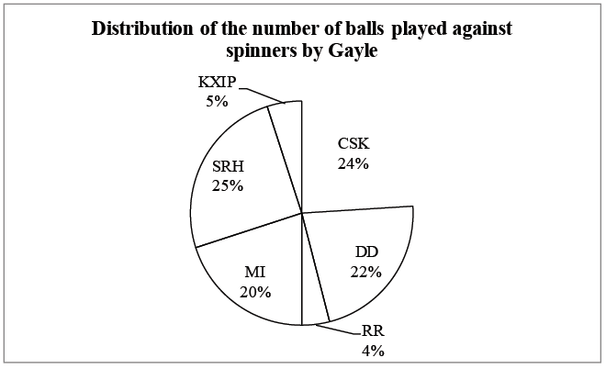

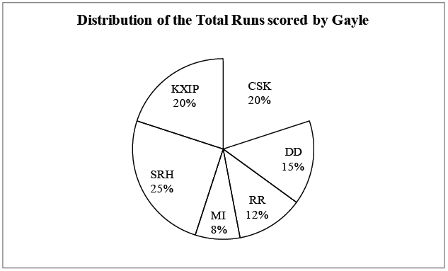

**Note:**

I. Each ball of fast bowlers was either left alone or hit for a 4.

II. Each ball of spinners was either left alone or hit for a 6.

III. Total number of balls played by Gayle is 800.

IV. He played 160 balls against DD.

V. Gayle scored a total of 1200.

14. What can be the maximum number of 4's hit by Gayle in the complete season?

a. 284

b. 300

c. 288

d. 282

15. What could have been the maximum number of runs scored by Gayle?

a. 3200

b. 3600

c. 4000

d. 4400

16. Minimum number of balls hit by Gayle us RR is:

a. 28

b. 18

c. 24

d. 16

17. Which of the following statements is definitely true regarding the performance of Gayle?

a. The number of 6's hit against DD is more than that in RR.

b. The number of 6's hit against RR is less than that in CSK.

c. The number of 6's hit against KXIP is more than that in RR.

d. None of the above

18. What can be the maximum number of balls that Gayle can hit against SRH?

a. 120

b. 60

c. 75

d. 90

**Directions (Q. Nos. 19 − 23):** *The pie charts below show the distribution of various dishes at a food festival. There were 2 categories of dishes viz. Starters and Main Course.*

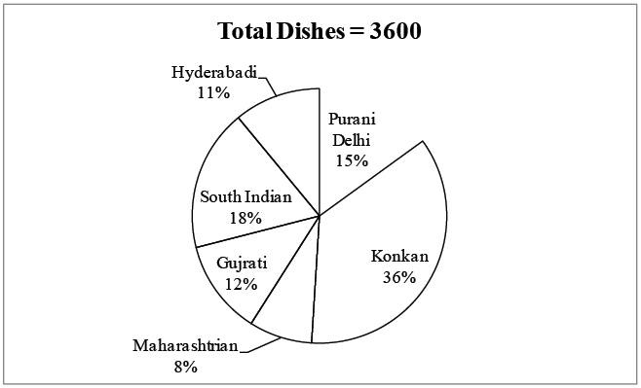

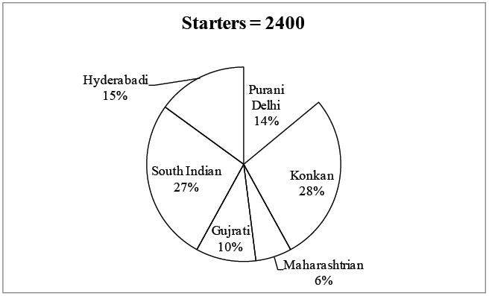

19. How many main course dishes are form Purani Delhi?

a. 184

b. 204

c. 216

d. 240

20. Which state has the minimum number of main course dishes?

a. Hydrabadi

b. Maharashtrian

c. Gujrati

d. None of these

21. What is the ratio of main course to starters from Konkan?

a. 12 : 13

b. 13 : 14

c. 14 : 13

d. 14 : 15

22. In the Purani Delhi cuisine by what percentage is the starter more/less than the main course items?

a. 16.83%

b. 53.18%

c. 147.05%

d. 64.70%